pROJECT ON CyberCafe Management System

**INDEX**

1. Introduction

2. Problem Definition

3. Requirement analysis

4. Existingsystem

5. Proposed system

6. System analysis

-Definition of Feasibility study

-Types of Feasibility study

7. Scope of the system

8. Structured analysis

- Entity Relationship Diagram

-Use Case Diagram

- Class Diagram

-Sequnce Diagram

-Activity Diagram

-Collaboration Diagram

9. Database Design

10. Implementation and Testing

- Test Cases

11. Sample Screen

12. Limitations & Future Enhancement of the system

13. Bibliography

**PROBLEM DEFINITION**

In existing system a lot of manual work has to be carried out. Large amount of paper work is involved which may cause high degree of error.

Registration of user names, keeping records of user are done manually, which is time-consuming process and there is possibility of making errors. Administrator has to keep the track of time, which is tedious job. Once the user logs out, while preparing bill, he has referred to user details including name, login time and time allocated leading to possibility of causing errors in bill calculation. This may be unbeneficial to administrator. Hence also there is not accuracy in bill calculation.

Also a lot of files, records are required to store these documents thus making it difficult to maintain.

Since all these reports are prepared manually, we require computer software for all these purposes.

**REQUIREMENT ANALYSIS**

Every user interacts with system with some needs and requirements such as:

1. Get data or information immediately.
2. Comprehensive information accessing and retrieving data to provide valuable reports.
3. Better utilization of time and manpower.
4. User should have basic knowledge of computer.
5. Every user must know the function of each master entry, transaction entry and reports.
6. User should know the format of database.

User must know the contents of main menu tool

### 

### EXISTING SYSTEM

In the form Cyber Café Managements System is manual system. In manual system administrator has to keep the track of many tasks such as keeping track of time, which is the tedious job. Once the user logs out, while preparing bill he has to refer user details including name, login time and logout time and time allocated leads to the possibility of causing errors in bill calculations. This may be unbeneficial to administrator.

Hence also there is not accuracy in bill calculations.

**FEASIBILITY STUDY**

* **DEFINITION**

The preliminary investigation is carried out before the analysis in which the Feasibility study is carried out. An important outcome of preliminary investigation is the determination that the system requested is feasible or not. Feasibility study is undertaken to determine either possibility of improving the existing system or developing a new system.

Preliminary investigation is an important part of the system analysis. Before starting any system we have to determine whether the system is feasible or not. This study is known as the Feasibility study.

**Types of feasibility study:**

1. Technical Feasibility Study.

2. Economical Feasibility Study.

3. Operational Feasibility Study.

**1. Technical Feasibility Study :**

It includes the study like can work for project be done with current equipment , existing software technology and with available manpower?

For proposed system technical hardware requirements are --

Processor : Pentium

Memory : Minimum 32 MB RAM

Software Requirements:

1) Front end – Core Java and advance Java

2) Back end - Microsoft Access

3) Platform - Windows XP or 98

**2. Economical Feasibility :**

The cyber cafe can easily afford software and hardware , since they are not expensive . Manual errors are minimized due to user friendliness of proposed system . Cyber cafe will not have to spend money on recruitment of highly skilled personnel in order to operate it.

Few days or hours of training to existing personnel is sufficient , since processing system was designed keeping in mind the common person with limited technical knowledge.

Hence, the proposed system is technically feasible.

**3. Operational Feasibility:**

Will the system be used if it developed and implemented?

Will there be resistance from the user to the new system.

The system will provide timely information and status of the various activities to manage, to facilitate the user of the system.

Smooth and user friendly operation of the system was main aim for spending up work in progress.

**Following are some good qualities of system:**

1. Master information is entered only once.

2. data processing is facilitated.

3. Faster processing of data to give structured reports. Hence, the proposed system is operationally feasible to cafe.

#### 

#### SCOPE OF THE SYSTEM

As this is automated cyber management system it makes it very easy for administrator to search details. Also it time allotment is done very efficiently and it provides fast service in term of the bill calculation and time management.

Which is very advantageous to both administrator and user.

E -RD

User

Register to

Administrator

Allocate time to

Delete

Chec-ks

Pays

Calculate

Balance

Recharge

Provides

Bill

Reduce

From

Add to

Facilities

**Class Diagram:-**

# 

**Sequnce Diagram**

# 

**Activity Diagram**



# Use case Diagram

# 

**Data Directory**

Balance

|  |  |  |
| --- | --- | --- |
| **FIELD NAME** | **TYPE** | **CONSTRAINT** |
| **Bid** | **Number** |  |
| **B date** | **Text** |  |
| **Aval balance** | **Text** |  |
| **Tottime** | **Text** |  |
| **Login time** | **Text** |  |
| **Logout time** | **Text** |  |

Administretor

|  |  |  |
| --- | --- | --- |
| **FIELD NAME** | **TYPE** | **CONSTRAINT** |
| **A_lname** | **Text** |  |
| **A_Pwd** | **Text** |  |

Member

|  |  |  |
| --- | --- | --- |
| **FIELD NAME** | **TYPE** | **CONSTRAINT** |
| **M id** | **Number** |  |
| **M name** | **Text** |  |
| **Day** | **Text** |  |
| **Month** | **Text** |  |
| **Year** | **Text** |  |
| **Gender** | **Text** |  |
| **Addr** | **Text** |  |
| **Type** | **Text** |  |
| **Mobile** | **Text** |  |
| **Email** | **Text** |  |
| **Day1** | **Number** |  |
| **Month 1** | **Number** |  |
| **Year1** | **Number** |  |
| **Amount** | **Number** |  |
| **Day 2** | **Number** |  |
| **Month 2** | **Number** |  |
| **Year2** | **Number** |  |

Amount

|  |  |  |
| --- | --- | --- |
| **FIELD NAME** | **TYPE** | **CONSTRAINT** |
| **Aid** | **Text** |  |
| **No of print** | **Text** |  |
| **Pamnt** | **Text** |  |
| **No of scan** | **Text** |  |
| **Samnt** | **Text** |  |
| **Extra pay** | **Text** |  |
| **Rembalance** | **Text** |  |

**Test Plan for CyberCafe System**

1. **General Information**

* 1. **Summary :**

**We are testing the application of Sales management System which maintains and helps in day-to-day transaction of Sales Department.**

* 1. **Environment and Pre-Test Background :**

**This application is being tested in SIBAR (MCA Dept) Computer Lab. No prior testing has been done on this application.**

* 1. **Test Objective :**

* **Authentication and Authorization.**
* **Member Details**
* **Time Details**
* **Balance Details.**
* **Bill Details.**
* **Report Details.**
  1. **Expected Defects :**

* + - **Open Defects**
    - **Close Defects**
    - **Known Defects**
  1. **References:**

[**www.wikipedia.com**](http://www.wikipedia.com)

[**www.google.com**](http://www.google.com)

1. **Plan**
   1. **Software Description**

|  |  |  |  |
| --- | --- | --- | --- |
| **Sr. No** | **Process** | **Input** | **Output** |
| **1.** | **Login Details** | **Customer Information.** | **Stores in Database Prompt message to user for completion** |
| **2.** | **Member Details** | **Member Information** | **Stores in Database Prompt message to user for completion** |
| **3.** | **Time Details** | **Time Information** | **Stores in Database Prompt message to user for completion** |
| **4.** | **Balance Details** | **Balance Time Information** | **Stores in Database Prompt message to user for completion** |
| **5.** | **Bill Details** | **Generates Bills** | **Stores in Database and provide Bill details after completion** |

* 1. **Test Team:**

**Test team will have following members:**

* + - 1. **Tester: Tester will perform the actual testing.**
      2. **Business Expert: Business Experts are those people who have knowledge about the business domain.**
      3. **Test-Team Manager: Test-Team Manager will be monitoring the whole testing process.**
      4. **User: User is the End user who will be actually dealing with the software.**

**c. Testing:**

**1. Schedule:**

**2. Requirement:**

**1. Computer with Java 1.6.0 and MYSQL Software installed on it.**

**2. We will require Software requirement Specification document & Vision Document.**

## *Specifications & Evaluations:*

## *a. Specifications:*

**1. Business Functions:**

* **Give Specification: This will help user to give the requirements of his related to project online.**
* **Member Details: This will help the Organization to keep information of his member and will provide facilities to access it.**
* **Time Generation: This will provide functions for generating Timing of customer who has given allotted.**
* **Report Generation: This will generate various reports demanded by the member usage and growth of company.**

**2. Structural Functions:**

* **Give Specifications:**

**User will have to register for that Application form will be provided.**

**After Registration, User will have Member ID and Password.**

**System will be Allot time for the member for the usage.**

* **Usage Details:**

**If user is a staff member of organization then he will be able to view details.**

**If user is Admin then we will provide him facilities to Add, Edit as well as Delete Details.**

**3. Customer Information:**

**If user is a member of organization then he will be able to add Customer details as well as can view details.**

**If user is a manager of Organization then we will provide him facilities to Add, Edit as well as Delete Customer Details.**

**For viewing information of particular Customer, we are providing search option.**

**4. Bill Generation:**

**User will be provided with two tabs by clicking which he can generate Invoices.**

**User will be provided with interface where either he can give customer name or customer id for generating bill.**

**5. Report Generation:**

**User will be provided with list of Reports using which he can generate report by clicking on those options**

**User will be provided interface where he need to give dates of which report has to be enervated.**

**According to the Report, user will need to give details on basis of that detail report will be generated.**

**4. Functional Requirement:**

|  |  |  |
| --- | --- | --- |
| **Sr. No** | **Functions** | **Test** |
| **1.** | **Give Specification** | **Usability Correctness Reliability Security Performance Maintainability Visibility** |
| **2.** | **Member Details** | **Maintainability Correctness Security Usability Visibility** |
| **3.** | **Timing Details** | **Maintainability Correctness Usability Visibility** |
| **4.** | **Balance Details** | **Maintainability Correctness Security Usability Visibility** |
| **5.** | **Report Generation** | **Security Reliability Correctness Understandability Visibility** |
| **6.** | **Bill Generation** | **Security Reliability Correctness Understandability Visibility** |

**5. Evaluation:**

|  |  |  |  |
| --- | --- | --- | --- |
| **Sr. No** | **Objectives** | **Priorities** | **Completeness Criteria** |
| **1.** | **Adding Data** | **High** | **System should Add data into the database. It should also prompt acknowledgement to the user.** |
| **2.** | **Updating data** | **High** | **System should update the old data with new updated data. System should check the authentication of user and then make changes to the database. It should prompt message to the user about updating.** |
| **3.** | **Deleting data** | **High** | **System should Remove the data demanded by the user from the database. It should check the authentication of the user before deleting the record. It should also confirm that a message is prompted to user about deletion confirmation.** |
| **4.** | **Searching data** | **High** | **System should retrieve data from database when search option has been clicked. If data is not found relevant to user demand, a message should be displayed to the user about data not present.** |
| **5.** | **Report Generation** | **High** | **After selecting particular report, Data related to that report should be properly retrieved from the database in proper format.** |
| **6.** | **Invoice Generation** | **High** | **System should retrieve data of only that customer whose id or name is mentioned by the user.** |

**3. Test Cases:**

**3.1 Test Case for Customer Registration**

**ABSTRACT**

**Library of test cases is the document having Common test cases for major objects in an application. New objects test cases can be added to it to maintain the library in efficient manner. Since these are the common test cases for objects, Quality Assurance Engineers who involved in writing test cases for your project edit these based on the project requirements.**

**CONTENTS**

**1. User ID**

**2. Password**

**3. User Name**

**4. Customer Address**

**5. Mobile Number**

**6. Date**

**7. Email Address**

|  |  |  |  |  |  |
| --- | --- | --- | --- | --- | --- |
| **Sr.No** | **Test case Id** | **Object** | **Test Description** | **Execution Steps** | **Expected Behavior** |
| **01** | **User Name** | **Text box** | **Checking the functionality “User Name” text box.** | 1. **Entering the value as "12345"** 2. **and clicking on the "Save" Push button** 3. **Entering the value as "/*--+-" and clicking on the "Register" Push button** 4. **Entering the value as "12354/*--+-" and clicking on the "Login" button** 5. **Entering the value as Null Characters and clicking on the "Login" button** 6. **Entering the value as " " blank space and clicking on the "Login" button** | 1. **Should show the popup error**     **message "Invalid entry. Name accepts only characters". After clicking the Login button in the message the cursor should focus on the textbox.**   1. **Should show the popup error message "Invalid entry. Name accepts only characters". After clicking the Login button in the message the cursor should focus on the textbox.** 2. **Should show the popup error message "Invalid Login. Name accepts only characters". After clicking the ok button in the message the cursor should focus on the textbox.** 3. **Should show the**   **popup error message "Please enter User Name". After clicking**  **the Login button in the message the cursor should focus on the textbox.**  **5. Should show the popup error message "Invalid Login. Name accepts only characters". After clicking the Login button in the message the cursor should focus on the textbox.** |
| **02** | **Customer Address** | **Textbox** | **Checking the functionality of the Customer Address text box.** | 1. **Entering the value as "12345" and clicking on the "Save" Push button.** 2. **Entering the value as "/*--+-" and clicking on the "Save" Push button** 3. **Entering the value as "12354/*--+-" and clicking on the "Save" Push button** 4. **Entering the value**   **as Null Characters and clicking on the "Save" Push button**   1. **Entering the value as " " blank space and clicking on the "Save" Push button** 2. **Entering the value as "a to z" and clicking on the "Save" Save button** | 1. **Should show the popup error message "Invalid entry. Address accepts only characters". After clicking the ok button in the message the cursor should focus on the textbox.** 2. **Should show the popup error message "Invalid entry. Address accepts only characters". After clicking the ok button in the message the cursor should focus on the**   **textbox.**   1. **Should show the popup error message "Invalid entry. Address accepts only characters". After clicking the ok button in the message the cursor should focus on the textbox.** 2. **Should show the popup error message "Please enter Address". After clicking the ok button in the message**   **the cursor should focus on the textbox.**   1. **Should show the popup error message "Invalid entry. Address accepts only characters". After clicking the ok button in the message the cursor should focus on the textbox.** 2. **Should accept the value and show the pop up message as “Enter City of Customer”.** |
| **03** | **Gender** | **Combo box** | **Checking the functionality of the "Gender" Combo box.** | 1. **Entering the value as "Male/Female" and clicking on the "Save" Push button.** 2. **Entering the value as " " blank space and clicking on the "Save" Push button** 3. **Entering the value as Null Characters and clicking on the "Save" Push button** | 1. **Should accept the value and show the pop up message as "Please enter Pin-Code". After clicking the Save button in the message the cursor should** 2. **focus on the "Male/Female" textbox.** 3. **Should accept the value and show the pop up message as "Please enter Value". After clicking the save button in the message the cursor should focus on the "Pin-Code" textbox.** 4. **Should not accept the value and show the popup error message that "Enter Value should not be blank". After clicking the**   **ok button in the message the cursor should focus on the textbox.**   1. **Should accept the value and show the pop up message as "Please enter Pin-Code". After clicking the ok button in the message the cursor should focus on the "Pin-Code" textbox.** |
| **04.** | **Date Of Birth** | **Combo box** | **Checking the functionality of the "DOB" Combo Box**  **Which accepts Characters and Numbers.** | 1. **Entering the value as "abcd" and clicking on the "Save" Push button.**   **2. Entering the value as "/*--+-" and clicking on the "Save" Push button**  **3. Entering the value as " " blank space and clicking on the "Save" Push button**  **4. Entering the value as Null Characters and clicking on the "Save" Push button**  **5. Entering the value as "0 to 9" and clicking on the "Save" Push button** | **1. Should accept the value and show the pop up message as "Please enter Date.". After clicking the ok button in the message the cursor should focus on the "Dateof birth" Combo Box.**  **2. Should Not accept the value and show the pop up message as "Please enter Pin-Code". After clicking the ok button in the message the cursor should focus on the "Pin-Code Combo Box.**  **3. Should not accept the value and show the popup error message that "Enter Specific date should not be blank". After clicking the ok button in the message the cursor should focus on the Combo Box**  **4. Should show the popup error message "Please enter the Contact". After clicking the ok button in the message the cursor should focus on the Combo Box**  **5. Should accept the value and show the pop up message as "Please enter Date of birth.". After clicking the ok button in the message the cursor should focus on the "Date Of Birth." Combo Box** |
|  |  |  |  |  |  |
| **05** | **Email** | **Textbox** | **Checking the functionality of the "Email" Textbox** | 1. **Entering the valid email address with " @ and ." and clicking on** 2. **the "Save" Push button** 3. **Entering the invalid** 4. **email address without " @ and ." and clicking on the "Save" Push button** 5. **Entering the value as Null and clicking on the "Save" Push button** | 1. **Should accept the Email address and should show a message as** 2. **"Personal profile Updated successfully"** 3. **Should show a pop up** 4. **error message that "Invalid entry. Enter a valid Email address". After clicking the ok button in the message the cursor should focus on the textbox.** 5. **Should show the popup error message "Please enter the Email address". After clicking the ok button in the message the cursor should focus on the textbox.** |
| **06** | **Mobile No** | **Text box** | **Chcking the functionality of the Mobile No Txtboxes should accept only numeric "0 to 9"** | 1. **Entering the value as "abcd" and clicking on the**   **""Save" Push button**   1. **Entering the value as "/*--+-" and clicking on the "Save" Push button** 2. **Entering the value as "abcd/*--+-" and clicking on the "Save" Push button** 3. **Entering the value as " " blank space and clicking on the "Save" Push button** 4. **Entering the value as "0 to 9" and clicking on the "Save" Push button** | 1. **Should show the popup error message "Invalid entry. Phone** 2. **no accepts only numeric value". After clicking the ok button in the message the cursor should focus on the textbox.** 3. **Should show the popup error** 4. **message "Invalid entry. Phone no accepts only numeric value". After clicking the ok button in the message the cursor should focus on the textbox.** 5. **Should show the popup error message "Invalid entry. Phone no accepts only numeric value". After clicking the ok button in the message the cursor should focus on the textbox.** 6. **Should show the popup error message "Invalid entry. Phone no accepts only numeric value". After clicking the ok button in the message the cursor should focus on the textbox.** 7. **Should accept the value and should show a message as "Personal profile Updated successfully"** |

Login Screen:

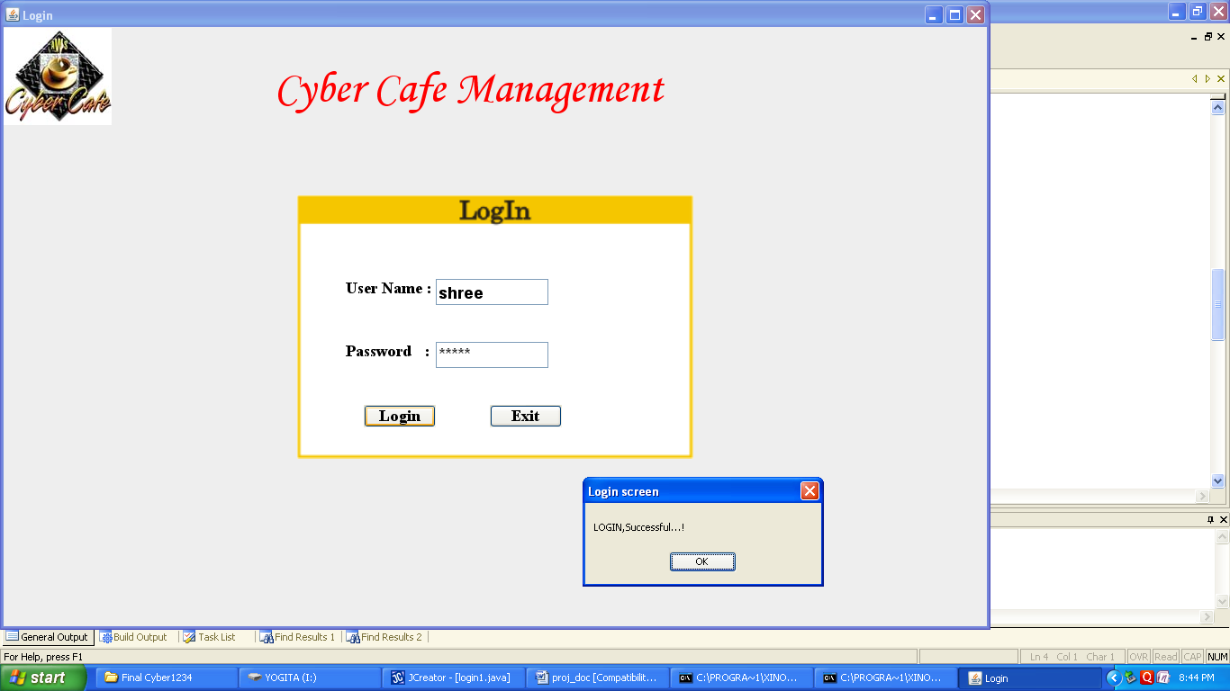

**Main Frame:**

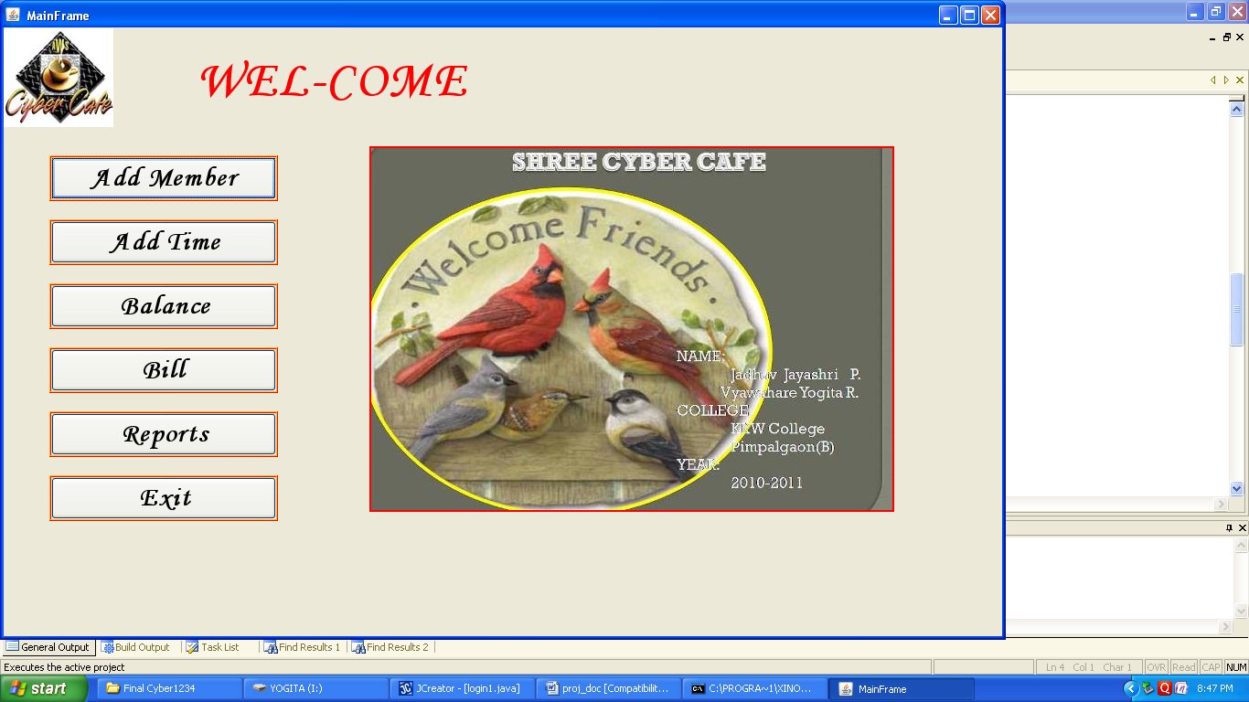

**Member Details:**

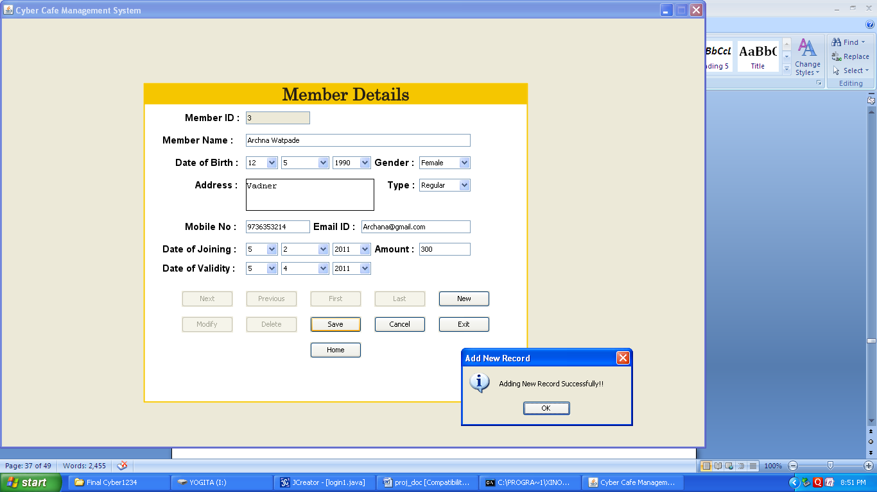

**Time Details:**

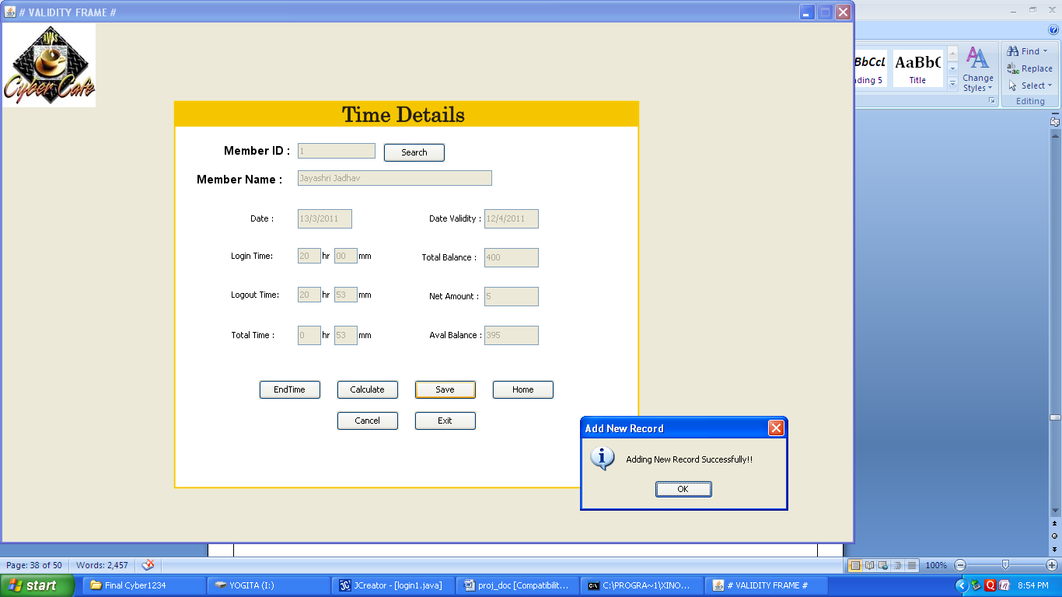

**Balance Details:**

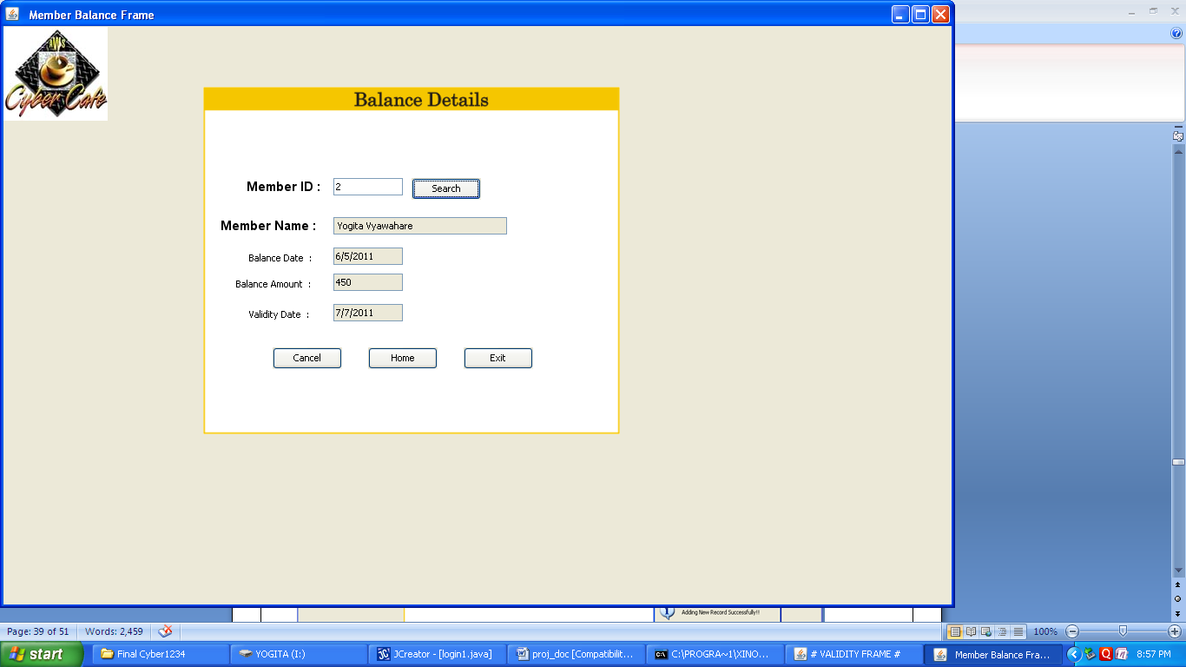

**Bill Details:**

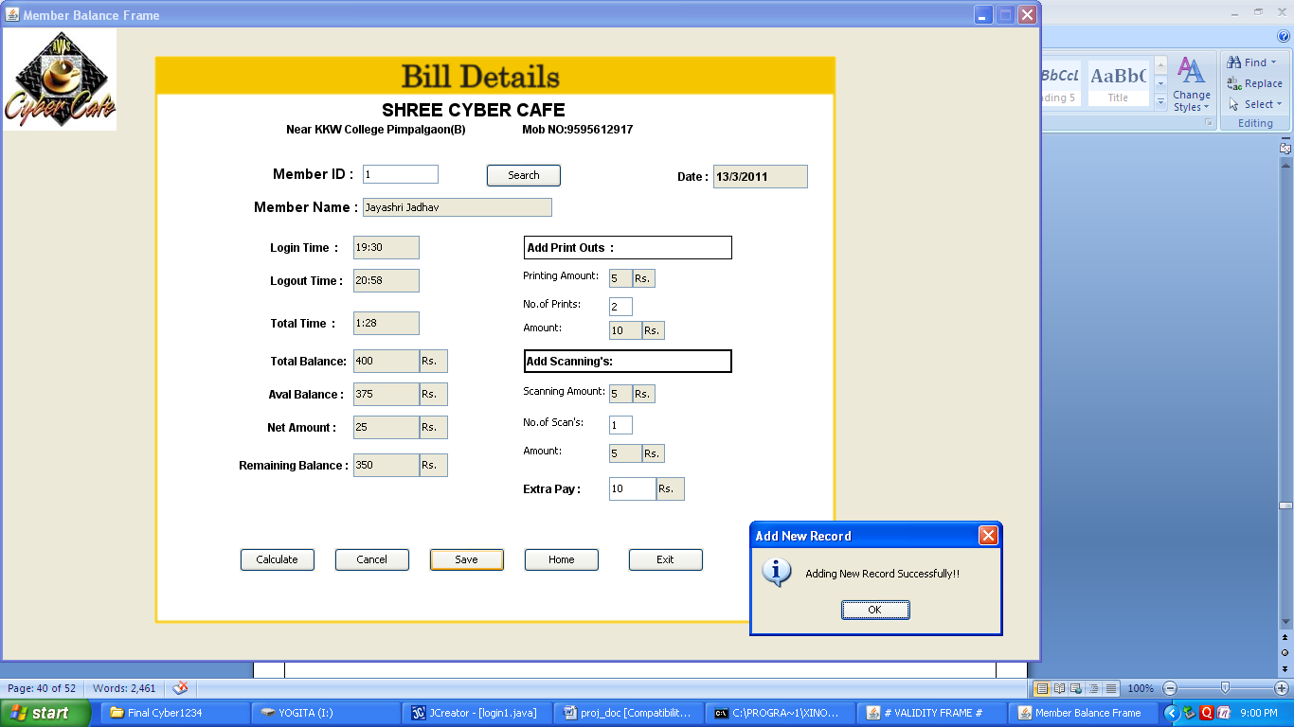

**Report:**

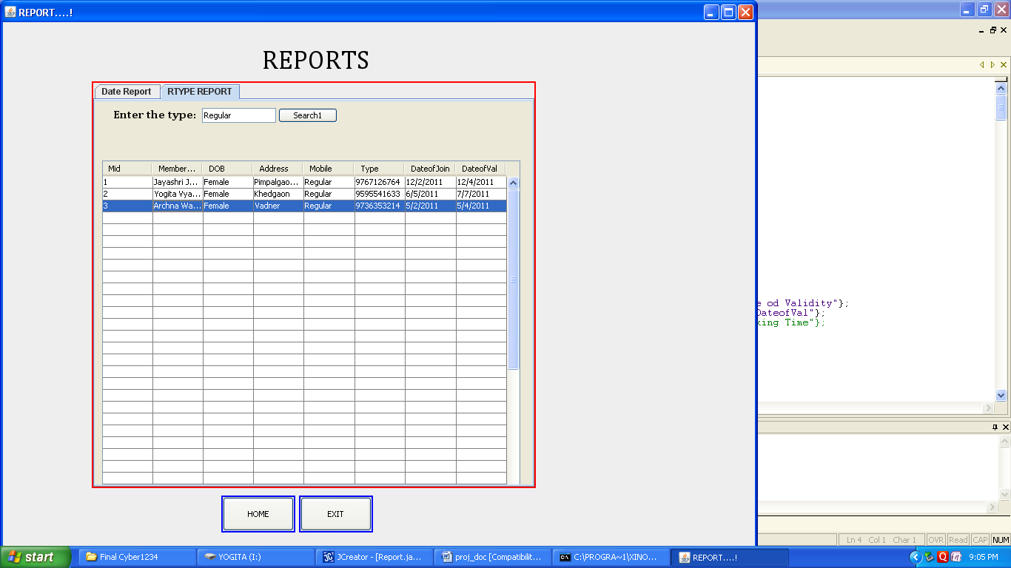

LIMITATIONS AND FUTURE

ENHANCEMENTS OF THE SYSTEM

LIMITATIONS :

The most important limitation of the existing system is , it is Manual system.

Drawbacks of Manual System:

* Time required for validation and updating is more.
* Accuracy is less and incomplete.
* Searching is difficult.
* Repetition of work is going on.
* Keeping track of cabin status is tedious job.

FUTURE ENHANCEMENTS:

The computerized “Cyber Café Management “ is made with intention to make easy to maintain the records and minimize the drawbacks of the system.

Advantages of computerized system over manual system are:

* Computerized system is completely automated thus user can operate easily.
* Time required is very less to makes and search the records.
* Computerized system generates online reports.
* It reduces the data consistency and redundancy.
* Computerized system is very helpful to display all records.

# Bibliography

**Reference Books:-**

⌂ **Black Book:**

-By Steven Holzner

⌂ **Java 2: The Complete Reference Book**

-By Herbert Schildt